Section 32 SQL databases

Structured Query Language

Resource links

<https://www.mycompiler.io/view/08q0XDT7TFp>

<https://www.w3schools.com/sql/sql_primarykey.asp>

<https://www.w3schools.com/sql/sql_datatypes.asp>

<https://sqliteonline.com/#fiddle-5bbdbaef7288bo2ajn2wly03>

W3 Schools SQL Tutorial

<https://www.w3schools.com/sql/>

types of DBs

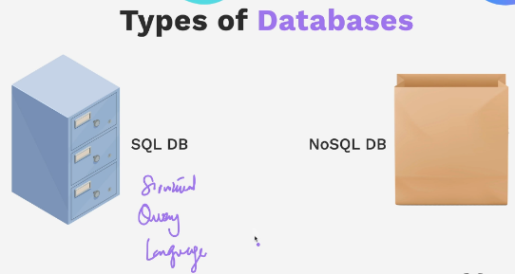

Data in SQL also know as a relational DB is stored in tables – tables created and then data stored in them

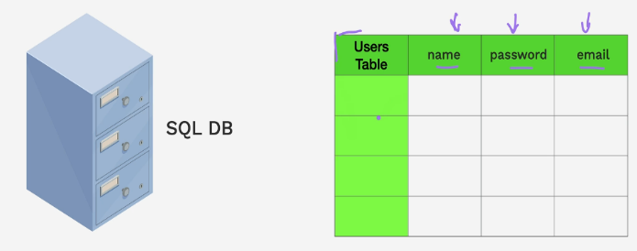

Tables can have relationships to other tables

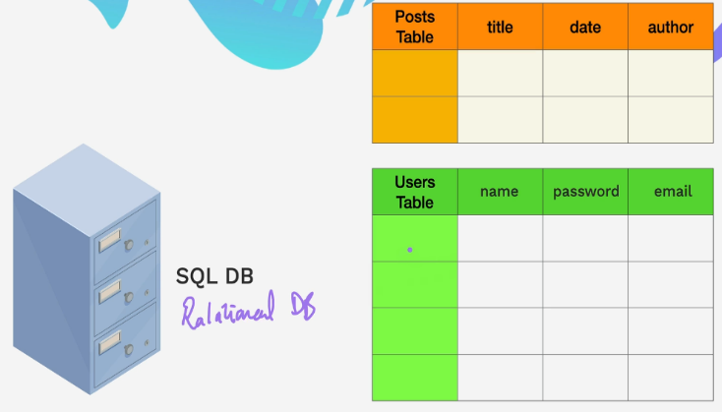

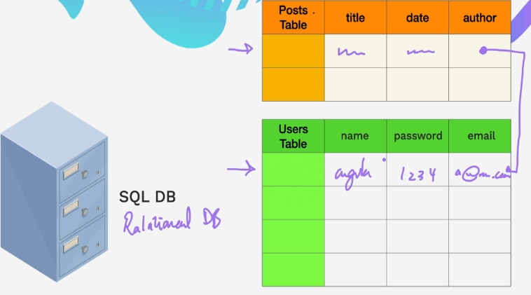

Oracle DBs very expensive but some open source are available

No SQL DB – documents created like JSON objects with key value pairs, its very flexible and data structure can be changed later without having to recreate the DB . Some scalability

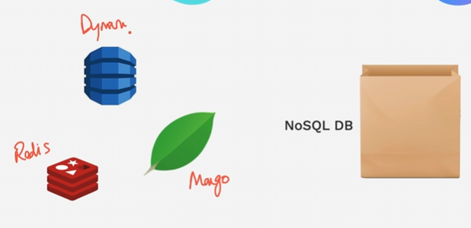

2010 to 2018 , No SQL got really popular but now the tides have turned and SQL is back on top.

Its queries are faster and No SQL did not live up to its hype of being scalable

Its SQLs structure leads to more consistent code structure

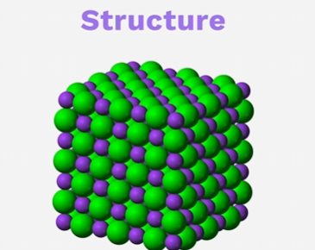

PostgreSQL is open source and very popular

W3 Schools SQL Tutorial

<https://www.w3schools.com/sql/>

In every db you essentially need to do these things -CRUD

On line tool for trying out sql db – this does not work.

<https://sqliteonline.com/#fiddle-5bbdbaef7288bo2ajn2wly03>

From the W3 docs syntax to created a table

More lesson resources

<https://www.mycompiler.io/view/7ZK5EPwt68f>

Inner Join

<https://www.w3schools.com/sql/sql_join_inner.asp>

Foreign Key

<https://www.w3schools.com/sql/sql_foreignkey.asp>